2 Qualitative Research Genres
Qualitative methodologists attempt to organize the various genres or approaches into categories or strands; this can be useful for proposal writers, who can situate their study within one of these strands. We refer to these as methodological currents of thought, employing Schram’s (2006) quite useful phrase to describe theoretical and empirical strands that inform a conceptual framework. Historically, this categorizing was relatively straightforward; with the amazing proliferation of genres, however, the task has become more challenging. This chapter provides a brief summary of the historical, canonical ways of organizing qualitative research genres, followed by discussions of genres that offer alternatives, at times with a focus on a specific population and often from a critical stance with emancipatory goals. Our purpose here is to help proposal writers situate their studies to provide a more nuanced argument for the specific approach.

Historically, qualitative methodologists developed typologies to organize the field. (We refer you to the sixth edition of this book for brief historical details.) Almost twenty years ago, Patton (2002) provided a substantial list of theoretical orientations in qualitative inquiry; this list included, in part, ethnography, autoethnography, phenomenology, symbolic interaction, ecological psychology, systems theory, chaos theory, and grounded theory. The evolution of this thinking is evident in the fourth edition of his book (Patton, 2015), where ethnomethodology, semiotics, hermeneutics, postmodernism, and narrative inquiry are added. In 2005, Denzin and Lincoln recognized case studies; ethnography, participant observation, and performance ethnography; phenomenology and ethnomethodology; grounded theory; life history and testimonio; historical method; action and applied research; and clinical research. This was updated in 2018, when they added ethnodrama/ethnotheater, visual methods, and a focus on social justice inquiry to grounded theory. Creswell has consistently (1997–2017) articulated five major genres and has continued this typology through the fifth edition of his book (Creswell & Poth, 2017): narrative research, phenomenology, grounded theory, ethnography, and case study. Merriam and Tisdell (2016) describe six common qualitative research designs: basic qualitative research, phenomenology, ethnography, grounded theory, narrative inquiry, and qualitative case studies. We also mention Ravitch and Carl (2016), who list nine approaches: ethnography and critical ethnography, case study research, action research and participatory action research, case study research, evaluation research, grounded theory, narrative inquiry, phenomenology, and practitioner research. See Table 2.1 for a comparison.

Table 2.1 Canonical Typologies of Qualitative Research

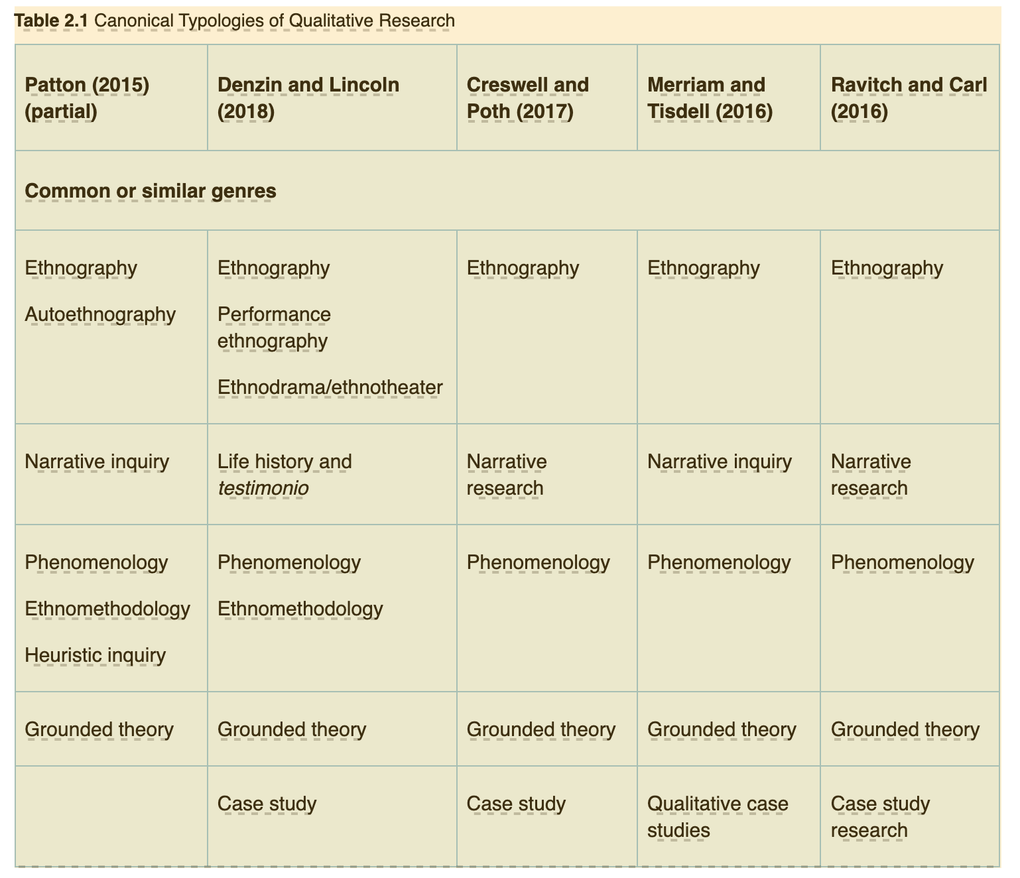

Are you interested in society and culture? Or individual lived experience? Or language and communication?

Building on the discussion provided in Gall et al. (2020), analysis of these lists, especially those with similar entries, shows a focus on a specific level or “unit of analysis”: (1) society and culture, as seen in ethnography, action research, case studies, and often grounded theory; (2) individual lived experience, as exemplified by phenomenological approaches, some feminist inquiry, and life histories; and (3) language and communication—whether spoken or expressed in text—as in sociolinguistic approaches, including narrative analysis, critical discourse analysis, and conversation analysis. Below, we offer short descriptions of these canonical genres before turning to those genres that offer more explicit opportunities for critical qualitative inquiry.

We note here and below that the term critical has become problematic in social inquiry. Many use it vaguely and loosely, seeming to expect the reader to know precisely what is meant by this ambiguous term. Clearly, many refer to “critical theory,” which itself is a huge and contested field. Others imply that using the term provides legitimacy to their work, placing it squarely among those who seek to raise and address issues of power, dominance, social inequities, and damaging discriminatory practices in the social world. We note here that one of the typologies listed above, that of Ravitch and Carl (2016), foregrounds the potential “criticality” of qualitative inquiry. We ask that, as with any vague and perhaps contested term, proposal writers be clear and specific and fully describe those critical scholars who inform their work.

Canonical genres have a long history in qualitative inquiry.

In our discussion of the canonical genres, below, we have also included notes on grounded theory and case study approaches, as well as arts-based inquiry. None of these maps fit neatly into one of the three foci listed above, as a researcher relying on grounded theory approaches, case study methodology, or arts-informed inquiry could focus on a group or organization (society and culture), on individuals, or on arts as culturally produced “texts.” While first articulated by Eisner (1991), arts-informed qualitative inquiry has witnessed a growing focus that may well be a result of the recent explosion in the access to and use of the Internet and social media networking. Instant access to images and videos through the Internet and social networking has encouraged, in part, the development of this genre, where a multiplicity of images, sounds, and perhaps even odors are integrated into a single research project. We discuss arts-informed inquiry below, noting its increasing visibility in the qualitative research landscape. Thus, the major genres we list in this seventh edition include ethnographic approaches, phenomenological and narrative approaches, sociolinguistic approaches, grounded theory and analysis, case studies, and arts-informed inquiry. A few of the sections discussing the various genres have been written by our current or former graduate students. We indicate this by listing their names as authors of those sections.

Canonical Genres

A Focus on Society and Culture: Ethnographic Approaches

Ethnography is the hallmark of qualitative inquiry and, as Patton (2015) notes, “the earliest distinct tradition” (p. 81). Derived from anthropology and qualitative sociology, ethnographies study human groups, seeking to understand how they collectively form and maintain a culture. Thus, culture is a central concept for ethnographies. Focusing on an analysis of actions and interactions within the group, culture “describes the way things are and prescribes the ways people should act” (Rossman & Rallis, 2017, p. 82).

Classical ethnographers used the terms emic and etic. We critique this as too simplistic.

Ethnographers—those who inscribe (graph) the culture (ethnos)—typically study groups, communities, organizations, or perhaps social movements through long-term immersion in the setting and by using a variety of data collection methods. Through the primary approach of participant observation (discussed in Chapter 6), ethnographers describe and analyze patterns of interactions, roles, ceremonies and rituals, and artifacts of that cultural group. Historically, ethnographers have drawn on the constructs of “emic” and “etic” to capture what was once seen as two separate worldviews: The emic was considered the insider’s perspective, while the etic was thought of as the outsider’s—the researcher’s. These terms have been relied on over the years. Our stance, however, is that the notion of differing insider–outsider perspectives on culture is a true binary and, hence, not particularly useful in learning and writing about shifting, sometimes contradictory, understandings of a particular culture or cultural group, whether those understandings belong to members of the group or the researcher. Our position is that the boundary inherent in the emic–etic binary is artificial.

Classical ethnography has been enriched by variations on its central principles and practices. Internet ethnography and critical ethnography are discussed briefly below, as are autoethnography (see Ellis & Bochner, 2016) and performance ethnography (see Denzin, 2003). These variations offer flexible approaches, but all derive from the foundational principles of classical ethnography.

A Focus on Individual Lived Experience: Phenomenological Approaches

Phenomenological approaches seek to explore, describe, and analyze the meaning of individual lived experience: “how they perceive it, describe it, feel about it, judge it, remember it, make sense of it, and talk about it with others” (Patton, 2002, p. 115). Derived from the German philosophy of phenomenology (see, e.g., Husserl, 1913/2012), this family of approaches (including hermeneutics as a methodology for examining text) typically involves several long, in-depth interviews with individuals who have experienced the phenomenon of interest. Analysis proceeds from the central assumption that there is an essence to an experience that is shared with others who have also had that experience. The experiences of those participating in the study—those who have had a similar experience—are analyzed as unique expressions and then compared to identify the essence. The focus is on life as lived.

As narrative approaches have burgeoned and as an example of the increasing hybridity of the large field of qualitative inquiry, one could argue that narratives and analyses of texts and talk are examples of interdisciplinary work with links to psychology (Bruner, 1990) and literature (Polkinghorne, 1988) that blends a focus on individual lived experience from phenomenology with the analysis of expressions of self found in narrative inquiry.

A Focus on Talk and Text: Sociolinguistic Approaches

Related to ethnographic approaches in their interest in understanding the meanings participants derive from and construct in social interactions and settings, sociolinguistic approaches focus on communicative behavior: talk and text. Researchers within this genre tend to record naturally occurring talk for analysis, although discourse analysts tend to embed talk in larger societal and cultural narratives (see Silverman, 2010, especially Chapters 6 and 7). The ubiquity of “talk” makes it quite generative for analysis. Specifically,

Face-to-face social interaction (or other live interaction mediated by phones and other technological media) is the most immediate and the most frequently experienced social reality. The heart of our social and personal being lies in the immediate contact with other humans. (Peräkylä, 2005, p. 874)

Analyzing talk, then, is a central focus for discourse analysis, critical discourse analysis, conversation analysis (see Peräkylä, 2005), and other variations within this genre. The focus for inquiry may be how particular speech events are accomplished, how identity is established and reproduced, or how social identity characteristics shape communicative behaviors. Recent critical examples in this genre focus on how “talk” expresses racist and other forms of oppression and aggression in everyday interactions (see Sue, 2010; Yosso et al., 2009). Also see recent work on bullying, including gaslighting—intimidation or psychological abuse (Sarkis, 2017).

Grounded Theory Approaches

Grounded theory aims to build general ideas organically.

First articulated by Glaser and Strauss (1967), grounded theory is an overall approach to inquiry with the primary purpose of generating theories that explain the interactions and/or settings of interest. In its original conception, grounded theory sought to build explanations of social phenomena by working backward, if you will, from data into theory, rather than through the more traditional approaches relied on in the social sciences at that time (from theory/hypothesis to data, back to theory). The term grounded theory was intended to capture this idea: Work began “on the ground,” prior to building theoretical insights. As such, it was somewhat revolutionary but soon suffered from substantial critique from other methodologists who argued that no researcher could enter “the field” without sensitizing concepts or working understandings (hypotheses) of the phenomena under investigation. Modifications to Glaser and Strauss’s (1967) ideas emerged as Strauss began to work with Corbin (Strauss & Corbin, 1990), developing constructivist grounded theory approaches stipulating that theories and data are constructed by the researcher in interaction with and interpretation of the social phenomena of interest; they are not discovered, as the original ideas of grounded theory suggested.

Recent work by Corbin and Strauss (2015) and especially Charmaz (2015) develops these ideas more fully. Central to grounded theory are approaches to analysis that include open coding and axial coding. Open coding is the process of identifying and naming the data. “Essentially, each line, sentence, paragraph etc. is read in search of the answer to the repeated question ‘what is this about? What is being referenced here?’” (Borgatti, n.d., para. 8). More on coding is illustrated in Chapter 7. Through the comparative processes of axial coding, these categories are related to one other, frequently searching for causal explanations for events and interactions. The softening of Glaser and Strauss’s original ideas (especially by Corbin and Charmaz) makes them more accessible to many researchers who seek to make theory-building contributions about the phenomena that interest them.

Case Studies

Case studies are widely used among qualitative researchers because of their explicit focus on context and dynamic interactions, often over time. While many assume that case studies rely only on qualitative methods, such is not the case. One of the strengths of the case study approach is its methodological eclecticism; a variety of methods may be used, including those that generate quantitative data. The flexibility of the case study approach prompted Stake (2005) to note that “a majority of researchers doing casework call their studies by some other name” (p. 443).

What is a case? A person, an event, a group, an organization, a movement . . . an example of a larger phenomenon.

However, when relying primarily (or exclusively) on qualitative methods, the researcher may be informed by the assumptions or strategies of a variety of qualitative genres. A case study could be primarily ethnographic but also draw on critical discourse analysis, thus blending genres. Single-standing genre or not, case studies present many advantages, chief among them being the flexibility to incorporate multiple perspectives, data collection tools, and interpretive strategies. However, the merits of the case study as a qualitative genre face skeptics (Stake, 2005) as well as supporters (Creswell & Poth, 2017; Krueger & Casey, 2014; Yin, 2017). Many methodologists have contributed to contest the misplaced objections against the value of case studies (Flyvbjerg, 2011; Kennedy, 1979; Yin, 2017).

Even though there have been many attempts to define the case study, and despite the variations existing among these definitions, the centrality of contextualized deep understanding is recognized almost uniformly. Case studies favor intensity and depth, as well as exploring the interaction between case and context (Flyvbjerg, 2011). Also widely recognized is the need for defining the unit of analysis—an individual, a small group, an intervention—and setting boundaries around the case (Yin, 2017). When many cases are available for study, it is necessary to clarify the selection process; for instance, one may be interested in a particular case in and of itself (an intrinsic case), or one may wish to explore a case as an illustration of a larger phenomenon (instrumental case), and one could even be interested in exploring several instances of a phenomenon (multiple case study; Stake, 2005). While different criteria are acceptable depending on the study, researchers should be able to present rationales for selection depending on purpose and intended use. Selection criteria may include researchers’ familiarity with the case and the case’s intrinsic significance, among many other criteria (Thomas, 2011b). Once the case has been carefully selected and defined, researchers may draw on data collection and analytical strategies according to the unique opportunities and challenges the case presents.

Given the interpretative nature of qualitative inquiry, it is possible to state that, rather than merely identifying and isolating a case, researchers reconstruct it. The critical and postmodern turns in qualitative inquiry, characterized by skepticism toward master narratives and grand theories, open new spaces for epistemological debate. As a result, the discussion has departed from arguing the case study’s ability to establish generalizations and has been directed toward phronesis (Thomas, 2011a). Phronesis involves practical, contextualized knowledge—“practical wisdom, common sense” (Flyvbjerg, 2011, p. 313; see also, Thomas, 2010, 2011a). These ideas are not new to qualitative inquiry, and yet they may foster a resurgence of case study research as a means to construct practical knowledge that is responsive to its environment.

Arts-Informed and Multimodal Inquiry

Rachael B. Lawrence

Arts-based and arts-informed qualitative research is an emerging genre of qualitative inquiry. Although only recently recognized in the formal research literature, this line of inquiry may not be so new (Harvard University, 2008). Theorists and practitioners of arts-based and arts-informed research view the distinction between arts and sciences as an artificial bifurcation of formerly interrelated and intertwined thought processes and activities; viewing “the arts” and “research” as separate processes may, in some ways, harm both fields (Barone & Eisner, 2012; Butler-Kisber, 2010; Sullivan, 2010). Would Leonardo da Vinci the inventor have been able to visualize as he did without arts training? Would Albert Einstein the violinist have conceptualized relativity without musical training? Would Caroline Herschel have discovered comets or theorized about space without training on the opera stage? Because the fields of arts and sciences were not so distinct in the past, many researchers are examining ways the two fields can work together to generate knowledge and understanding.

Think about how your study might be enhanced with arts-informed notions.

Because the arts play a key role in the way people make sense of their worlds and surroundings, “arts-based researchers consciously place creative and critical processes at the core of research process so as to fully investigate the contexts that shape complex human thoughts and actions” (Sullivan, 2010, p. 58). Instead of standing as separate disciplines, the arts and inquiry can dynamically inform each other. Research can inform the development of artistic pieces, and the arts can inform research at nearly any point of the journey. Arts-based or arts-informed research means that artistic processes or artistic pieces are incorporated in the development, data collection, and/or analysis of the project, or that they are being used to represent findings. Consider how the act of drawing or painting may help with the conceptualization of a project, or how poetry may be a tool for data analysis. Are there times when a dramatic play, film, photograph collection, collage, or musical piece may serve as a trustworthy and powerful way to present findings? Arts-based and arts-informed researchers believe so (see Margolis & Pauwels, 2011; Pink, 2012a; Rose, 2012).

* * * *

In the past four decades, a critical turn has taken place in the social sciences, humanities, and applied fields. Some qualitative researchers have espoused postmodern, postpositivist, and postcolonial theoretical perspectives that critique traditional social science (see De Zengotita, 2018; Gandhi, 2019; Seidman, 2016). The level of commitment to and engagement with these theoretical perspectives presents significant variation. While these critical approaches occasionally lead to fresh new approaches to data generation, analysis, and presentation, attaching the word critical or the prefix post- has at times become an academic performativity to signal one’s currency in the field or, worse, a box that has to be checked. These scholars challenge the historical assumption of neutrality in inquiry and assert that all research is interpretive and fundamentally political, spoken “from within a distinct interpretive community that configures, in its special way, the multicultural, gendered components of the research act” (Denzin & Lincoln, 2005, p. 21). Luker (2008) describes this as our “fishiness”:

Whether we know it or not, we are guided by our taken-for-granted assumptions about what constitutes “good,” “rigorous” methods whenever we undertake to do research. How could we not be? The studying of the social order is itself a social process, so how could the process of doing it not be surrounded by assumptions, fetishes, beliefs, and values that are not simply mirror reflections of objective reality, if there is such a thing? . . . We are fish studying water, and our very fishiness shapes how we think about it. (p. 31)

This argument underscores that research involves issues of power and that traditionally conducted social science research has silenced many marginalized and oppressed groups in society by making them the passive objects of inquiry. Qualitative research is deemed especially guilty because of its historical complicity with colonialism (Bishop, 2005), especially when anthropologists’ understandings of culture could provide tools for colonizers. Those espousing critical perspectives have developed research strategies that are openly ideological and have empowering and democratizing goals. Some of these can be understood as “counternarratives,” as they situate themselves as challenging the historical, neutral image of social science and its sometimes totalizing grand narratives. Of these, we see various forms of narrative analysis, including autoethnography and testimonio, as counternarratives; such studies explicitly take on the hegemonic grand narratives of dominant voices and seek to find a legitimate space for life experiences to be heard. Given this goal of telling one’s story, these genres can be seen as having assumptions consistent with phenomenological approaches. Such may well be the case and represents another example of the increasing hybridity of methodological choices even under the large umbrella of qualitative inquiry.

An interdisciplinary approach with many guises, critical narrative analysis seeks to describe the meaning of experience for those who frequently are socially marginalized or oppressed, as they construct stories (narratives) about their lives. Life histories, biographies and autobiographies, oral histories, and personal narratives are all forms of narrative analysis. Each specific approach assumes that storytelling is integral to understanding lives and that all people construct narratives as a process in constructing and reconstructing identity (Sfard & Prusak, 2005). Some approaches focus on the sociolinguistic techniques a narrator uses, others on life events and a narrator’s meaning making. When framed by feminist or critical theory, narrative analysis also can have an emancipatory purpose (Chase, 2005), as when stories are produced and politicized as counternarratives to prevailing oppressive “grand narratives” (discussed below under autoethnography, critical race, critical feminist, and queer theory).

We list several more critically informed genres in Table 2.2 and provide brief discussions of their key approaches and assumptions below. Rather than a comprehensive list, we think of critical as an umbrella term that includes many different epistemological traditions.

Table 2.2 Critical Genres of Qualitative Research

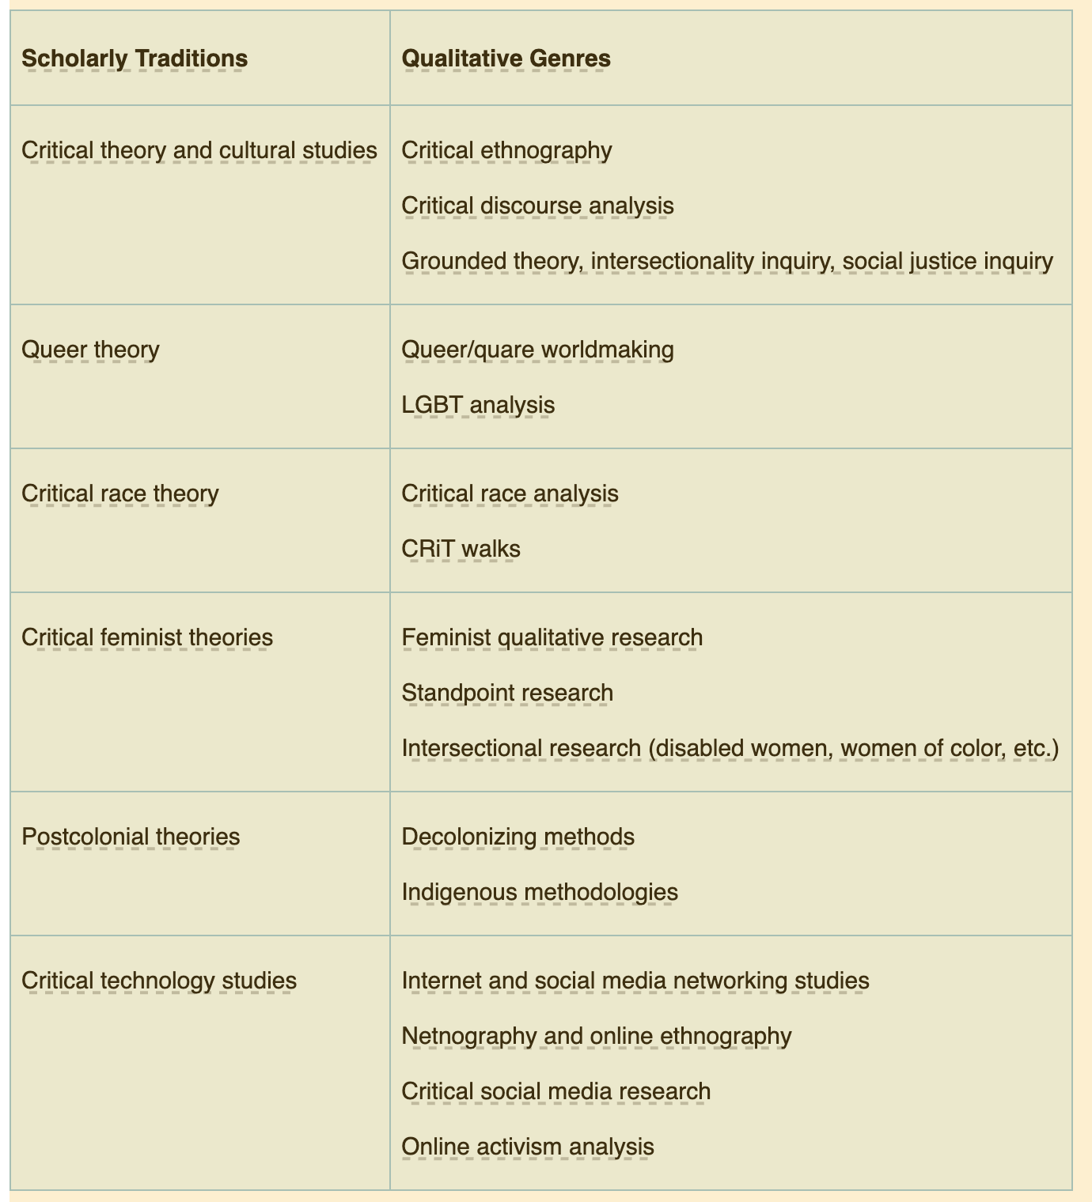

Critical has become normative. Think deeply—and read widely—to inform yourself what this construct means and how you might espouse it.

We argue that either canonical or critical assumptions can undergird each of the major and specialized genres. Canonical qualitative research assumes that (a) knowledge is not objective Truth but is produced intersubjectively; (b) the researcher learns from participants to understand the meaning of their lives but should maintain a stance of neutrality; and (c) society is reasonably structured and primarily orderly and predictable. Postmodern and postcolonial perspectives also assume that knowledge is subjective and must be challenged and critiqued. Similarly, critical theory; critical race, critical feminist, and queer theory; and cultural studies also assume that knowledge is subjective but view society as essentially conflictual and oppressive. These positions critique traditional modes of knowledge production (i.e., research) that have evolved in settings structured to legitimize elite social scientists and to exclude other forms of knowing. Critical race theorists, critical feminist researchers, and those espousing postcolonial perspectives point to the exclusion of “peripheral” knowledges and truths from traditional knowledge production (Alcadipani et al., 2015; Delgado et al., 2017; Liegghio & Caragata, 2020). By means of such challenges, it becomes clear that the assumptions behind research questions should be interrogated, deconstructed, and sometimes dismantled and reframed.

Such inquiry could contribute to radical change or emancipation from oppressive social structures, either through a sustained critique or through direct advocacy and action taken by the researcher, often in collaboration with participants in the study. All these critiques share five assertions:

(1) Research fundamentally involves issues of power; (2) the research report is not transparent, but rather it is authored by a raced, gendered, classed, and politically oriented individual; (3) race, class, and gender [among other social identities] are crucial for understanding experience; (4) historically, traditional research has silenced members of oppressed and marginalized groups; and (5) systems of divisions and oppression were historically constructed and are continuously reinforced. (Rossman & Rallis, 2017, p. 80, emphasis added)

These more critical perspectives on qualitative research contain three injunctions: As researchers, we should

1.examine how we represent the participants—the Other or the subaltern (Spivak, 1998)—and search for their counternarratives and modes of domination (Seidman, 2016) in our work;
2.scrutinize the “complex interplay of our own personal biography, power and status, interactions with participants, and the written word” (Rossman & Rallis, 2017, p. 80); and
3.be vigilant about the dynamics of ethics and politics in our work.

One implication of these concerns is that qualitative researchers pay close attention to their participants’ reactions and to the voice they use in their work as a representation of the relationship between themselves and their participants. Another is that the traditional criteria for judging the adequacy or trustworthiness of a work have become essentially contested. As a result, the novice researcher might be left floundering for guidance as to what will constitute thoughtful and ethical research. We discuss these issues in Chapter 3.

As noted above, those frustrated with traditional qualitative research may find greater flexibility of expression in critical ethnography, autoethnography, critical discourse analysis, action and participatory action research, queer theory and analysis, critical race theory and analysis, gender studies, cultural studies, or Internet ethnography, to mention a few of the more critical genres under the qualitative inquiry umbrella. Each embraces changing existing social structures and processes as a primary purpose and, when framed by explicitly critical orientations, has openly political agendas and often emancipatory goals. We briefly discuss each genre below.

Application Activity 2.1 Situating Yourself

Imagine you are embarking on a study of immigrants to the United States via its southern border. You are passionate about helping find ways to better serve migrant youth as they seek better life opportunities in the United States.

Consider the canonical and more critical genres discussed in this chapter. Are you inclined to a more critical theoretical grounding or not? This is a first decision. Then consider which of the genres discussed appeals most to you. Ask yourself the following:

- Am I interested in the lived experiences of a few individuals?
- Am I interested in communication patterns among migrant youth and customs officers?
- Am I interested in new patterns of social engagement that emerge in camps holding these youth?

Ponder where you feel most comfortable focusing your gaze. Discuss with your critical friends how such a focus could be well served by various genres.

Critical Genres

Critical Ethnography

Critical ethnography is grounded in theories assuming that society is structured by class and status, as well as by race, ethnicity, gender, and sexual orientation, to maintain the oppression of marginalized groups. As defined by Madison (2012), “critical ethnography begins with an ethical responsibility to address processes of unfairness or injustice within a particular lived domain” (p. 5, emphasis in the original). Historically, critical ethnography developed from the commitment to radical education in several works sharply critical of accepted teaching practice (hooks, 1994). In education alone, critical ethnography has exploded to more than 1,500 articles (Beach & Vigo-Arrazola, 2020). Critical ethnography can also go beyond the classroom to ask questions about the historical forces shaping societal patterns, as well as the fundamental issues and dilemmas of policy, power, and dominance in institutions, including their role in reproducing and reinforcing inequities such as those based on gender, class, and race (Thériault, 2016; Vigo-Arrazola & Dieste Gracia, 2020).

Importantly, critical ethnography embraces studies that explore identity construction, as individuals and groups evolve to develop an understanding and a way of coping within the constraints of societal views of the “correct” way of being. We note that the emergence of intersectionality (Hill-Collins, 2019) encourages research to focus on the ways class, race, and gender, for example, intersect. This is apparent during the current pandemic and attendant economic upheaval, where both are interrelated and affect marginalized communities disproportionately. For example, Miled (2019) interrogated her positionality when doing critical ethnography to examine the intersections of gender, age, and religion by exploring the experiences of young Muslim women.

We should also note here the recent development of postcritical ethnography, which moves beyond critical ethnography to explicitly incorporate postmodern perspectives. This discourse community develops critical social narratives that are ethnographies in the traditional sense but in which the involved social scientist explicitly takes a political stand (Everhart, 2005). Postcritical ethnographers use narrative, performance, poetry, autoethnography, and ethnographic fiction as their forms of representation. Their goal is to take a stand (like participatory action researchers) and have greater impact than that allowed by a 20-page article in an academic journal or a book read by 40 people (Noblit et al., 2005). In another example, Anders and Lester (2019) engaged with postcritical ethnography to explore the loss experienced by Burundian refugees living in U.S. Appalachia. They explain that, at its core, “postcritical work is justice work” and this justice work can be “civil, political, economic, social, cultural and racial” (Anders & Lester, 2019, p. 925). While presenting their findings in a traditional academic journal article, they engage with performance, playing with spacing, alignment, and capitalization in a style that resembles poetry or spoken-word performance.

Another of postcritical ethnography’s forms of representation that has entered the lexicon of qualitative scholars is the notion of performance. Performance ethnography has become a critical mode of representing ethnographic materials, “the staged reenactment of ethnographically derived notes” (Alexander, 2005, p. 411). Embodying cultural knowledge through performance not only depicts cultural practice but might also lead to social change, as actors and audience reconceptualize their social circumstances. This genre finds representation in popular theater (Erel et al., 2017), arts-based studies (Barone & Eisner, 2012; see above in arts-informed inquiry), music (Said, 2007), and other media. It also evokes the notion of “cultural performance”: the methods and resources available to members of a community or social identity group to construct and reconstruct (perform) those identities (Teman & Saldaña, 2019).

Autoethnography

More closely related to autobiography than traditional ethnography, autoethnography is a reflexive approach to understanding the human condition through critical and engaged analysis of one’s own experiences. For historical context within the field of sociology, Ellis (see, especially, 1986) turned to autoethnography following public condemnation of how participants in the ethnographic study of “fisher folk” in Tidewater, Maryland, were treated (see Allen, 1997, for details). Although a precise definition is difficult, autoethnography is both a method and a product. Through self-observation and analysis of various personal artifacts, autoethnographers seek to produce personal stories and narratives that depict their lives, based on the assumption that these aspects of their lives resonate with the experiences of others. At their best, autoethnographies are counternarratives that challenge the predominant grand narratives of a particular aspect of the social world by providing alternative, deeply personal viewpoints. Examples include Boylorn (2013), Ellis and Bochner (2016), Hughes and Pennington (2017), and Larsen (2014). However, at times autoethnographies become intellectual “navel-gazing,” revealing intimate details of lives that seem out of place (to some) in social science discourse. This has led some to call for a “moderate” approach to autoethnography, characterized by balancing “innovation, imagination” on one hand and “rigor and usefulness” on the other (Stahlke Wall, 2016, p. 1).

The rise of autoethnography within qualitative inquiry parallels the extraordinary increase in opportunities for public self-disclosure found in contemporary society. Personal blogs; reality television shows that invite sharing of intimate details; YouTube, where one can share personal video clips instantaneously—all have fostered or encouraged the kind of self-disclosure that autoethnography represents. The rise of digital autoethnography (Atay, 2020) illustrates the many new opportunities that online lives provide qualitative researchers.

Critical Discourse Analysis

Critical discourse analysis focuses on issues of power, and on the ways linguistic expression reflects uneven distribution between dominant and marginalized populations (Rogers, 2004). This focus on discourse, which includes talk and text, explores how language shapes lives. Under the umbrella of critical discourse analysis, it is possible to identify strategies that are grounded in different ontological and epistemological assumptions. The term discourse is interpreted and used in vastly different ways (Mills, 2004). All critical discourse analysis approaches share a commitment to reveal and confront dominant discourses and ideology through careful consideration of spoken and written language, and even nonverbal expression. A critical-realist strand of critical discourse analysis relies on Marxist assumptions, in line with Frankfurt School–style commitment to critical theory and ideology critique. In contrast, post-structuralist approach to discourse analysis is at the same time based on and critical of structural linguistics (De Saussure, 2011). Most critical discourse analysis approaches take a critical stance, recognize that reality is socially constructed, and embrace social action or change as the ultimate goal of their analytical process (J⊘rgensen & Phillips, 2002).

The French theorist Michel Foucault has become influential across the social sciences (Gane, 2018) over the past three decades. Foucault (1972) proposed turning familiar or taken-for-granted discourses into unfamiliar entities to be analyzed in connection with their specific environments. Taken-for-granted ideas about prisons, mental illness, and sexuality were the focus of Foucault’s studies, but the principles have been applied to schools, universities, and nearly every aspect of social life.

Despite the value of efforts intended to systematize the craft of critical discourse analysis, it is important to emphasize that there is not a step-by-step process to follow even though some useful guides are available. For instance, Boréus and Bergström (2017) outline eight approaches to discourse analysis, including argumentation and metaphor analysis. Wodak and Meyer (2016) present multiple approaches to discourse analysis grounded in different theoretical traditions. Some strategies shared across approaches are comparing texts, substituting elements in the text for others to elucidate relations among elements, identifying different voices or perspectives, and conducting close detailed analysis; these strategies have the purpose of identifying patterns and exploring the implications of different discursive constructions (Machin & Mayr, 2013). While these steps are to be considered heuristics, standards of practice require critical discourse analysis to be “solid,” “comprehensive,” and “transparent” (J⊘rgensen & Phillips, 2002, p. 173).

Action Research and Participatory Action Research

Action research replaces the traditional social science claim of neutrality and objectivity to seek full, collaborative inquiry by all participants, often to engage in sustained change in organizations, communities, or institutions (Stringer, 2007). It seeks to decentralize traditional research by staying committed to local contexts rather than to the quest for Truth and to liberation of research from its excessive reliance on the “restrictive conventional rules of the research game” (Guba, 1978, as quoted in Stringer, 1996, p. x). When ideally executed, action research blurs the distinctions between researcher and participants, creating a democratic inquiry process. It is often practiced in organizational contexts and in education, where professionals collaboratively question their practice, make changes, and assess the effects of those changes (Kemmis & McTaggart, 2005; McNiff & Whitehead, 2003; Sagor, 2005). Also active in social work, business management, and community development (Hollingsworth, 1997), researchers who engage in action research do so to improve their practice.

Perhaps more visible in international work, participatory action research draws on the precept of emancipation, as articulated by Freire (1970), that sustainable empowerment and development should begin with the concerns of the marginalized (Krueger-Henney & Ruglis, 2020). In addition to an explicit commitment to action, the hallmark of participatory action research is full collaboration between researcher and participants in posing the questions to be pursued and in gathering data to respond to them. It entails a cycle of research, reflection, and action. Examples include research from a feminist perspective (M. Fine & Torre, 2019), research among indigenous populations (Mayazumi, 2009; Peltier, 2018), and research among youth (Ozer, 2017), along with many others.

Application Activity 2.2 Writing a Memo

In a short memo, describe and analyze how two different genres could be fruitfully combined—for example, a more ethnographic approach with critical discourse analysis, or participatory action research and arts-informed inquiry. The purpose of this memo is to clarify—for you—the potential for a hybrid approach. Share your memo with your critical friends for discussion and feedback.

Queer Theory and Analysis1

1 This section was originally written by Paul St. John Frisoli for the sixth edition and has been updated.

Stemming from lesbian feminism, post-structuralism, and the civil rights and gay and lesbian political movements of the 1960s, queer theory attempts to deconstruct social categories and binary identities to demonstrate the fluidity and transparency of otherwise demarcated boundaries within the social world. Judith Butler (1999) is considered the unofficial “founder” of queer theory. While the study of LGBTQ experiences, as an object of research, has steadily increased in education (Mayo, 2017), media studies (Cho, 2018), and most other fields, qualitative researchers recognize that theories and epistemologies grounded in these identities remain underrepresented. The term queer is subversive, contested, and uncomfortable to many (Alexander, 2018).

Naturally and definitively assumed standards such as heterosexuality are deconstructed to demonstrate that every aspect of a person’s identity is based on norms, rules, and cultural models (Jagose, 1996). To define these concepts as queer is to acknowledge the possibilities, fluidities, and processes and not fix them into a concrete discipline. As a result, queer theory does not solely highlight sexuality but recognizes “that identities are always multiple or at best composites with literally an infinite number of ways which ‘identity-components’ (e.g., sexual orientation, race, class, nationality, gender, age, able-ness) can intersect or combine” (Seidman, 1996, p. 11). Postcolonial queer theory scholars highlight the importance of recognizing the role of colonialism, postcolonialism, and globalization in imposing cultural imperialistic ideas of sexuality that fail to take non-Western cultures and histories into account (Altman, 2001). Contemporary critiques of racial injustice point out that LGBTQ movements and academia, including queer theory and queer studies, have remained predominantly white spaces, often suppressing people of color. Discussions about queer identities of color, sometimes called “quare,” and a focus on intersectionality have become central. Deconstruction, denaturalization, and subversion are at the core of queer/quare analysis. Used as a verb, “to queer” academia, research, or teaching means to disrupt assumptions. These principles continue to guide qualitative inquiry inspired by queer/quare theory.

Critical Race Theory and Analysis

Critical race theory (CRT) emerged from a strand of critical theorizing applied to the U.S. legal system called critical legal studies. With links to critical theory generally, the feminist critique of the principles and practice of law, and postcolonial theory, critical race theorists take up issues of racism, racial oppression, and racial discrimination as their central focus for analysis. Those within this genre argue that legal decisions—both historical ones and those belonging to the present day—reflect the intersection of racism, sexism, and classism, and that legal principles are applied unevenly, with race as the central differentiating quality. CRT has been influential in multiple fields, including social work and both K–12 and postsecondary education (Howard & Navarro, 2016; Patton, 2016). With health outcomes being segregated across racial lines, CRT has also been introduced to health research (Bridges et al., 2017).

Derrick Bell, the sometimes controversial legal scholar, is credited with initiating and sustaining the advocacy and ideology inherent in CRT with a persistent critique of the liberalism of the U.S. civil rights movement. (Bell’s legal papers, speeches, and academic publications are stored in the New York University Archives, available at dlib.nyu.edu/findingaids/html/archives/bell.) In the mid-1990s, the field of education began to take up the core arguments and analytic focus of CRT. Notable in this field is Ladson-Billings (2005, 2016; Ladson-Billings & Tate, 2006), whose work centered on issues of race in teaching practice and educational research. Ladson-Billings’s early work highlighted the pedagogical practices of teachers who had great success teaching African American students. Dixson (2005; Dixson & Rousseau, 2005, 2007) has applied the qualitative methodology of portraiture (see Lightfoot & Davis, 1997) to analyses of issues of race and racism, focusing specifically on “jazz methodology” (Dixson, 2005). Recent scholarship has taken a more critical approach, calling attention to anti-Black racism, introducing concepts like plantation politics, and engaging with social movements such as #BlackLivesMatter (Dancy et al., 2018; Squire et al., 2018).

Other methodologies associated with CRT include storytelling (narrative analysis) and the production of counterstories to balance the hegemonic, often white, representations of the experiences of Black people, Indigenous peoples, and people of color (BIPOC), primarily in the United States. Thus, CRT’s methodological emphasis on storytelling and its political commitment to counterhegemonic representations have links with postcolonialism’s emphasis on testimonio—giving witness to social injustices—and the production of counternarratives (Kiyama, 2018). More recently, hip-hop methodology has emerged as an approach to apply principles of CRT to research in educational settings (Martin, 2014). Other embodied approaches utilizing CRT include CRiT walking, which references both CRT and criticality, with attention to how walking can reveal how place, race, and education are interconnected (Hughes & Giles, 2010; Giles & Hughes, 2009).

Critical race theory and analysis takes up an explicitly political agenda, with its focus on racial discrimination, white supremacy, and advocacy for redressing past injustices. In its avowedly political stance, CRT has much in common with queer theory and analysis and with certain strands of feminism (especially the more critical strands), to which we now turn.

Feminist Studies and Methodologies

Feminist theories and methodologies can be used to frame research across issues and disciplines. These theories place gender relations at the center of any inquiry and usually have critical and emancipatory aims, with a focus on women. Early gender studies incorporated studies of how women and girls subconsciously act out normalized, socially constructed identity categories that serve specific purposes in society. Such studies grounded liberal feminism—a pursuit of equal rights. Gender studies include examination of videotaped interactions between mothers and young children that show the power of language in conveying gendered expectations for boys and girls (Gelman et al., 2004), how artifacts and spaces inscribe gender differences in kindergartens (Lyttleton-Smith, 2019), and the power of administrators to make schools inclusionary for trans children (Leonardi, 2018).

Feminist perspectives “uncover cultural and institutional sources and forces of oppression. . . . They name and value women’s subjective experience” (Marshall, 1997a, p. 12). Such theories help frame research, identifying “the political choices and power-driven ideologies and embedded forces that categorize, oppress, and exclude” (Marshall, 1997a, p. 13).

Gender is not the sole, essential, and fixed category identifying a person, but evolves within the intermeshing of intersectionality. Importantly, feminist perspectives increasingly incorporate the recognition of multiple intersectionalities of identity. Thus, gender, sexuality, race, religion, country of origin, language, age or generation, health and physical abilities, class, social networks, and so on all combine in fluid ways (Tong & Botts, 2017).

Feminist inquiry cautions against simplistic representations of women in developing countries to avoid concluding that some practice is oppressive without recognizing that women are making practical and political choices. As mentioned above, gender and sexuality are performative, meaning that individuals make choices within the local context (Mohanty, 2009).

By combining feminist and critical perspectives, scholars dismantle traditional policy analysis that has failed to incorporate women and create research agendas that turn critical thought into emancipating action (St. Pierre, 2000). Gender studies become feminist when they uncover systems of domination, such as the challenges made by Indonesian women to male dominance in shaman rituals as well as male dominance in school superintendent positions (Tarbutton, 2019), and studies of the effect of poverty and food insecurity on the relationships between boys and girls in South Africa (Bhana, 2005a, 2005b).

A plurality of strands of feminist theory frame different research goals (Avanza, 2020; Marshall & Edwards, 2020). For example, maternal, care, and cultural feminisms highlight ways women define womanhood and explore ways women and men construct different identities. Socialist/Marxist and radical feminisms explore how capitalism and historical systems of power are embedded in patriarchy as experienced by women. As Laible (2003, p. 185) notes:

Such theory can frame examinations of the state-imposed oppression of women in welfare, medical, and other systems the state regulates. They can identify how the institutional practices were developed in a way . . . that specifically benefits one group of people. [In the United States] that group is Euro-American, middle- to upper-class, and usually male, . . . [with] standard operating procedures tending to hurt those people who do not fit the above profile.

Postcolonial and Black feminisms highlight race, gender, and ethnic experiences of sex and gender relations. Many in non-Western nations criticize a rights-based approach to argue that gendered-sexual systems and practices are culturally bound, instead favoring a culturally relativist weaving of feminisms in analyses of gender-based violence, child brides, burqa wearing, and the like (Evans et al., 2014). Recent feminisms development adds an emphasis on ways economic systems control meta-discourses that persistently oppress and suppress women’s labor, needs, and voices (see Ferber & Nelson, 2009) to speak of “dangerous knowledge” (Bell et al., 2020) and explore intersectionalities in conservative women (Avanza, 2020) and the full range of sexual identities.

Feminist theories now move far beyond the demand that the voices and lives of women and girls be included in studies. This “add women and stir” response is inadequate. Feminist researchers have expanded qualitative inquiry especially by focusing on the power imbalances between the researcher and the researched, by expanding collaborative research, and by asserting that reflexivity is a strategy for embracing subjectivity, replacing pretenses of objectivity. Recent work focuses on Indigenous worldviews, drawing on postcolonial theory and perspectives (see Cannella & Manuelito, 2008; Mayazumi, 2009). Given the empowerment focus of Indigenous methodologies, they can also be usefully situated within the various strands of participatory action research. As the following quote illustrates, cultural practices can be described using a range of genres, notably autoethnography.

Walking on the land gave me a sense of my community, of the sacredness of the land, and of the spiritual dynamic of the space . . . which I now reclaim as my Indigenous knowledge. Is this not legitimate knowledge? . . . I did not learn this at school. (Mayazumi, 2009, p. 517)

The research approaches we have discussed so far point to the importance of identity, power, and oppression when conducting qualitative research. Figure 2.1 illustrates some of the most salient forms of oppression based on social identities. Qualitative researchers need to be attentive to these identities, and attached forms of oppression, not only in relation to research participants but also in relation to themselves.

Figure 2.1 Identity-Based Forms of Oppression
Source: Adapted from Marshall, Gerstl-Pepin, and M. Johnson (2020).

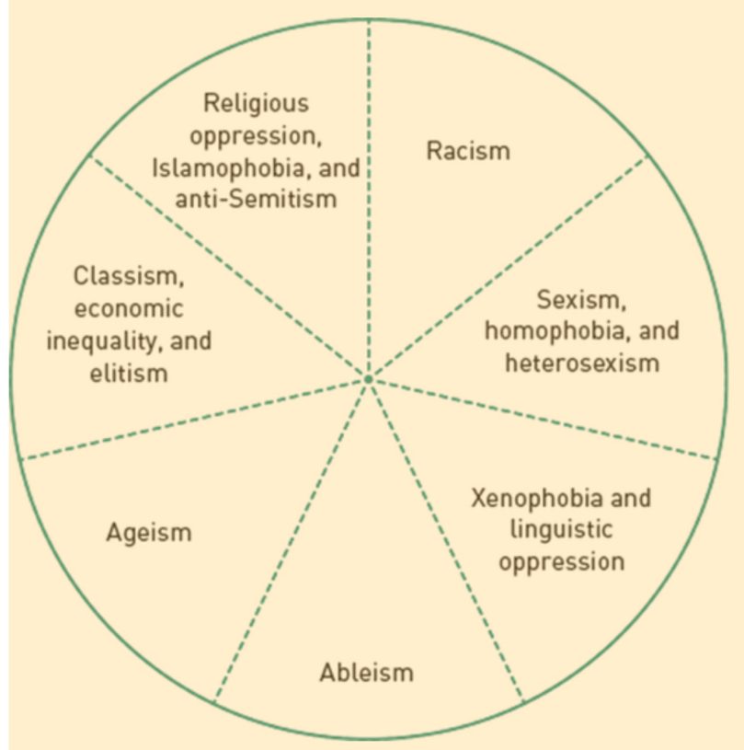

Cultural Studies

What are everyday representations of culture?
Think about social media.

The domain of cultural studies encompasses a broad range of perspectives and interpretations of culture that depart from the traditional manifestation, which is high culture. Stuart Hall (2018) and the Birmingham School have been central to the theoretical development of this field (Ang, 2020). Major themes throughout the discipline include acknowledging what we know, understanding the relationship of that knowledge to who we are (our identities), and examining the relationship between the “knower” and the one who is “giving” the knowledge. Gray (2003) explains that “one of the key characteristics of cultural studies is that of understanding culture as constitutive of and constituted by ‘the lived,’ that is the material, social, and symbolic practices of everyday life” (p. 1). Within this domain, scholars underline the importance of deconstructing the intersection of language, text, power, and knowledge to gain a better understanding of how we craft representations of our life worlds (Gray, 2003, 2004; Ryen, 2003; Saukko, 2008). These scholars argue that language and text, when associated with power, help shape how we see, differentiate, and interpret the world around us to find our place within it (Prior, 2004). Research is embedded within the meaning-making process, which can contribute to and endorse discursive representations that in turn objectify a research participant’s lived experiences. Research is part of the process of “forming the social mosaic” creating different social realities (Saukko, 2008, p. 471). Cultural studies examine these liminal spaces to “interrogate issues of domination and power” (hooks, 2004, p. 156) to surface different linguistic and textual interpretations and representations. This process relates to feminist theory and critical race theory, which break down essentialist notions of difference to offer opportunities for creating multiple discourses from voices that are frequently left out of the academy.

For qualitative researchers interested in cultural studies, a key idea in Stuart Hall’s sociology may be particularly useful: not only a commitment to emancipation (Winter, 2018) but also the importance of paying attention to representation and the generative notions of encoding/decoding. What was radical about the emergence of cultural studies was the rejection of high culture and the expansion of sources worthy of analysis. As a result, qualitative researchers may wish to expand their notions of what constitutes data and evidence to focus on everyday representations of culture, including social media.

Internet/Virtual Ethnography
Paul St. John Frisoli

Internet ethnographies can be fascinating but have special ethical considerations.

Emerging from the basic principles of ethnography, Internet ethnography, also known as virtual ethnography, is considered a method and methodology for conducting qualitative research. The Internet is loosely defined as a medium for communication, a venue to connect across physical borders, and a socially constructed space (Markham, 2004, p. 119). Therefore, this medium is seen as both a tool and a site for qualitative research, developed from the observation that social life in contemporary society communicates, interacts, and lives more online; for ethnographers to better understand the “social world,” they should adjust their research methods to reflect these changes (Garcia et al., 2009; Markham, 2004).

When the Internet is conceptualized as a tool, researchers may conduct and distribute e-mail or web-based surveys, interview participants either synchronously in chat rooms or asynchronously via e-mail, create discussion boards and group blogs, or suggest online journaling for participants. This method challenges the assumed rapport-building ethnographic approaches of “being there, being part of an everyday life of a community or culture” (Flick, 2006, p. 265). Critics argue that with Internet ethnography, there are “removed social context cues such as gender, age, race, social status, facial expression and intonation resulting in a disinhibiting effect upon group participants” (Williams, 2007, p. 7). However, others argue that though these methods may prevent the researcher and participants from interacting face-to-face, they allow for more reflective, participant-driven textual responses, especially when rigorous and systematic qualitative research principles are enacted (Flick, 2006; Garcia et al., 2009; Mann & Stewart, 2002, 2004; Williams, 2007). One advantage of using the Internet for qualitative studies is that it allows researchers to conduct interviews in remote areas of the world while sitting in their offices, maintain day-to-day synchronous and asynchronous communication, and speak with individuals who may not be able to participate in face-to-face interviews because of physical barriers or protection issues (Mann & Stewart, 2002). We provide more details on the Internet and computer applications as tools for research in Chapter 7.

When the Internet is conceptualized as a site for research, the focus shifts to understanding and analyzing the medium as a central feature of contemporary social life and, therefore, as noted above, ripe for study. Particularly relevant is the work of Markham (2004), who takes a cultural studies approach to legitimate use of the Internet as both a tool and a “discursive milieu that facilitates the researcher’s ability to witness and analyze the structure of talk, the negotiation of meaning and identity, the development of relationships and communities, and the construction of social structures as these occur discursively” (p. 97). As a result, Internet ethnography also identifies the World Wide Web as socially constructed virtual worlds (Hine, 2000) that can be researched to understand how people give meaning to their spaces. Virtual communities are graphical online environments in which people construct and represent their identities in the form of characters, also known as avatars. The avatars, representing research participants, are subject to participant observation to better understand the social construction of these virtual domains. Participating in these worlds may well ensure more anonymity, and participants may be more likely to disclose information when they are not inhibited by a face-to-face social hierarchy with the researcher (Garcia et al., 2009). The virtual can offer a sense of safety where individuals feel freer to reconfigure their identities to express themselves and relate to those who are like them (Markham, 2004).

However, this world is an uncertain one, and maneuvering through it has yet to produce context-specific, agreed-on research ethics such as privacy, identity authenticity, and informed consent. We discuss ethical issues associated with the Internet in Chapter 7. Researchers and participants alike are able to create their own identities that may differ from who they say they really are. Researchers can “lurk” online to begin identifying study participants without such individuals knowing (Mann & Stewart, 2004). It is also unclear if a researcher has the right to extract text from individuals’ blogs, discussion boards, and other publicly accessible information without permission. The Internet, as a new tool and site, is dynamic and fluid; its generativity for the development of qualitative research is just emerging.

Opportunities and Challenges

The preceding discussion is intended to provide ways of categorizing a variety of qualitative research genres and approaches, as well as briefly describe some of the emerging strands that derive from the critical, feminist, and postmodern critiques of traditional social science inquiry. As we note, systematic inquiry in each genre occurs in a natural setting rather than an artificially constrained one, such as a laboratory. The approaches, however, vary depending on theory and ideology, the focus of interest (individual, group or organization, or a communicative interaction, such as a text message or website), the degree of interaction between researcher and participants in gathering data, and the participants’ role in the research. The discussion was intended to provide some sense of the array of approaches under the qualitative research umbrella. This text, however, cannot do justice to the detailed and nuanced variety of qualitative methods; so we refer you to additional sources at the end of this chapter. Some of these sources are classic—the “grandmothers and grandfathers” in the field—others reflect emergent perspectives. Our purpose in this book is to describe the generic process of designing qualitative research that immerses researchers in the everyday life of a setting chosen for study. These researchers value and seek to discover participants’ perspectives on their worlds, and view inquiry as an interactive process between themselves and the participants. The process is descriptive, analytic, and interpretive, and relies on people’s words, observable behavior, and various texts as the primary data. Whether or not some single methodological refinement is qualitative could be debated in another arena. We hope to give practical guidance to those embarking on an exciting, sometimes frustrating, and ultimately rewarding journey into qualitative inquiry.

In the next chapter, we turn to the important considerations of trustworthiness and ethics. At the proposal stage, how might you argue that a study will address the canons of trustworthiness? And which ones? You should also demonstrate a deep sensitivity to the ethical issues that may arise during the conduct of the study.

Application Activity 2.3 Try It Out

Interview Each Other

Background: This will help you try out some skills and rev you up for understanding what is still to come in Chapters 3 through 9. Imagine you are collecting data for a study of families coping with stay-at-home orders due to the 2020 coronavirus pandemic. Assume that you have already gone through the institutional review board with some preliminary interview questions, you have sent out e-mails inviting people (both strangers and friends and friends of friends) to be respondents, and you’ve had follow-up phone conversations with the person you’re about to interview, setting up a time and place for the first of three 20-minute interviews.

Phase 1: Preparation with your group
With your group, discuss how to best use and modify the questions (5 minutes total).
Q.1: Tell me about what was going on with your family during the stay-at-home orders.
Q.2: Were there interactions going on that were unusual, given the ordinary family dynamics?
Q.3: Were there interactions that were delightful? Unexpected? Worrisome? Full of tension?
Discuss how you will handle rapport, role, reciprocity, ethics (5 minutes total).
Discuss any reservations you each have about your challenges and brag about your strengths for conducting this interview, especially if this were real research (5 minutes total).
Discuss how you’ll keep data so they are organized and easily analyzed and so you can come back to reexamine them for themes, data quality, how well your methods are working, etc. (5 minutes total).

Phase 2: Mock data collection
This will go in rounds so each of you will, in succession, play the role of interviewee, interviewer, and observer for 10 minutes’ worth of interview, then 3 to 4 minutes of debriefing. Be sure to rotate roles after about 10 minutes. The debriefing should be frank and tough, as well as appreciative, and include at least some of these elements:
As interviewee, you should talk about what things you liked about the interview and what worried or bothered you about the interviewer’s approach.As interviewer you should talk about things you felt you need to work on, things you thought about too late, risks you took, surprises, and regrets.As observer you should be clear and honest in telling your colleague about personal style, presentation, tone, timing, affect, probes, ethical sensitivities, and concerns about potential data quality.

Dialogue Between Learners

Hi, Karla,
I’m Keren, a doctoral student at the UNC-CH School of Education, working with Dr. Catherine Marshall. I was born and raised in Israel and came to North Carolina about 5 years ago to do an MA at UNC-CH. I had studied in the UK for an interdisciplinary MA in human rights and had worked in several grassroots organizations in Israel. Now, while working on my comprehensive examinations, I am writing about the contributions qualitative methods can have in the field. I am studying international development policies, especially those pertaining to gender equality in education. I am showing how the methodology helps us look critically at international policy formulation and implementation by examining local context and by listening to stakeholders usually ignored by statistical analysis. The field of international development has traditionally been overwhelmingly quantitative, so I often struggle with formulating qualitative exploratory questions for new contributions for the field.
Are you already in your dissertation writing phase? Did you always know you wanted to work with qualitative methodologies?
I look forward to learning more about your research interests and reflections.
Keren

Hi, Keren,
Thank you for the introduction. Your research and corresponding with you can help us both move through this process. I am an American doctoral student at the University of Massachusetts Amherst, working with Dr. Gretchen Rossman, and I am also concentrating on international education development issues. As I am currently in the writing phase of my dissertation, I look back seeing how choosing qualitative methods was an obvious choice. I am investigating the cultural relevancy of schooling practices and curriculum within a primary school in Senegal, using a compressed ethnographic approach. Because ethnographic approaches and my own values emphasize multiple and coexisting forms of knowledge, a qualitative research design allows me to deeply explore the nuances of participants’ experiences and to provide a rich and complex illustration of their schooling realities. I also struggled with my own positionality as an outsider in Senegal throughout my research. Again, qualitative methods were a good fit because they privilege reflexivity. I find that qualitative methods align well with the conceptual framework that I finally chose. I can assure you that it has been a difficult (but rewarding!) process.
I hope I’m not rambling, in response to your question. We can talk more about rationale later. Nice to be dialoguing with you!
Karla

Further Reading

Major Genres

On Ethnography
Atkinson, P. A., & Delamont, S. (Eds.). (2008). Representing ethnography: Reading, writing and rhetoric in qualitative research. SAGE.

Fetterman, D. (2020). Ethnography: Step by step (4th ed.). SAGE.

On Phenomenology
Caelli, K. (2000). The changing face of phenomenological research: Traditional and American phenomenology in nursing. Qualitative Health Research, 10(3), 366–377. https://doi.org/10.1177/104973200129118507

Kvale, S., & Brinkmann, S. (2015). InterViews: Learning the craft of qualitative research interviewing (3rd ed.). SAGE.

Sokolowski, R. (2013). Introduction to phenomenology. Cambridge University Press.

On Sociolinguistic Studies
Fairclough, N. (2005). Discourse analysis in organization studies: The case for critical realism. Organization Studies, 26(6), 915–939. https://doi.org/10.1177/0170840605054610

Roth, W.-M. (2001). Gestures: Their role in teaching and learning. Review of Educational Research, 71(3), 365–392. https://doi.org/10.3102/00346543071003365

On Grounded Theory
Borgatti, S. (n.d.). Introduction to grounded theory. Retrieved September 24, 2020, from http://www.analytictech.com/mb870/introtogt.htm

Charmaz, K. (2015). Constructing grounded theory: A practical guide through qualitative analysis (2nd ed.). SAGE.

Mills, J., Bonner, A., & Francis, K. (2006). Adopting a constructivist approach to grounded theory: Implications for research design. International Journal of Nursing Practice, 12, 8–13. https://doi.org/10.1111/j.1440-172X.2006.00543.x

On Case Studies
Hancock, D. R., & Algozzine, B. (2017). Doing case study research: A practical guide for beginning researchers (3rd ed.). Teachers College Press.

Thomas, G. (2011). A typology for the case study in social science following a review of definition, discourse, and structure. Qualitative Inquiry, 17(6), 511–521. https://doi.org/10.1177/1077800411409884

Yin, R. K. (2018). Case study research and applications: Design and methods (6th ed.). SAGE.

Specialized, Emerging, or Critical Genres

On Narrative Analysis
Kim, J. H. (2015). Understanding narrative inquiry: The crafting and analysis of stories as research. SAGE.

Riessman, C. K. (2008). Narrative methods for the human sciences. SAGE.

On Critical Discourse Analysis

Boréus, K., & Bergström, G. (2017). Analyzing text and discourse. SAGE.
Machin, D., & Mayr, A. (2013). How to do critical discourse analysis. SAGE.

Wodak, R., & Meyer, M. (2016). Methods of critical discourse studies. SAGE.

On Action Research
Herr, K., & Anderson, G. L. (2015). The action research dissertation: A guide for students and faculty (2nd ed.). SAGE.

Noffke, S. E., & Somekh, B. (Eds.). (2009). The SAGE handbook of educational action research. SAGE.

Stringer, E. T. (2013). Action research: A handbook for practitioners (4th ed.). SAGE.

On Participatory Action Research
Baum, F., MacDougall, C., & Smith, D. (2006). Participatory action research. Journal of Epidemiology and Public Health, 60(10), 854–857. https://doi.org/10.1136/jech.2004.028662

Van der Riet, M. (2008). Participatory research and the philosophy of social science: Beyond the moral imperative. Qualitative Inquiry, 14(4), 546–565. https://doi.org/10.1177/1077800408314350

On Critical and Postcritical Ethnography
Cruz, M. R. (2008). What if I just cite Graciela? Working toward decolonizing knowledge through a critical ethnography. Qualitative Inquiry, 14(4), 651–658. https://doi.org/10.1177/1077800408314346

Madison, D. S. (2020). Critical ethnography: Method, ethics, and performance (3rd ed.). SAGE.

Noblit, G. W., Flores, S. Y., & Murillo, E. G., Jr. (Eds.). (2005). Postcritical ethnography: Reinscribing critique. Hampton Press.

On Performance Ethnography
Bagley, C. (2008). Educational ethnography as performance art: Towards a sensuous feeling and knowing. Qualitative Research, 8(1), 53–72. https://doi.org/10.1177/1468794107085296

Madison, D. S., & Hamera, J. (Eds.). (2005). Handbook of performance studies. SAGE.

Miller-Day, M. (2008). Performance matters. Qualitative Inquiry, 14(8), 1458–1470. https://doi.org/10.1177/1077800408322589

On Arts-Informed Inquiry
Butler-Kisber, L. (2010). Qualitative inquiry: Thematic, narrative and arts-informed perspectives. SAGE.

Knowles, J. G., & Cole, A. L. (Eds.). (2008). Handbook of the arts in qualitative research: Perspectives, methodologies, examples, and issues. SAGE.

Rose, G. (2012). Visual methodologies: An introduction to researching with visual methods (3rd ed.). SAGE.

On Internet/Virtual Ethnography
Gajjala, R., & Mamidipudi, A. (2013). Cyber selves: Feminist ethnographies of South Asian women. AltaMira Press.

Hine, C. (2020). Virtual ethnography. SAGE. https://doi.org/10.4135/9780857020277
Kozinets, R. V. (2010). Netnography: Doing ethnographic research online. SAGE.

On Feminist Research
Butler, J. (1999). Gender trouble: Feminism and the subversion of identity. Routledge.

Cannella, G. S., & Manuelito, K. D. (2008). Feminisms from unthought locations: Indigenous worldviews, marginalized feminisms, and revisioning an anticolonial social science. In N. K. Denzin, Y. S. Lincoln, & L. T. Smith (Eds.), Handbook of critical and Indigenous methodologies (pp. 45–59). SAGE.

Collins, P. C. (1990). Black feminist thought: Knowledge, consciousness, and the politics of empowerment. Routledge.

Kleinman, S. (2007). Feminist fieldwork analysis. SAGE.
Liegghio, M., & Caragata, L. (2020). COVID-19 and youth living in poverty: The ethical considerations of moving from in-person interviews to a photovoice using remote methods. Affilia. Advance online publication. https://doi.org/10.1177/0886109920939051

On Cultural Studies
Barker, C. (2011). Cultural studies: Theory and practice (3rd ed.). SAGE.

Giardina, M. D., & Newman, J. L. (2012). Cultural studies: Performative imperatives and bodily articulations. In N. K. Denzin & Y. S. Lincoln (Eds.), The landscape of qualitative research (pp. 371–406). SAGE.

On Critical Race Theory
DeCuir, J. T., & Dixson, A. D. (2004). “So when it comes out, they aren’t that surprised that it is there”: Using critical race theory as a tool of analysis of race and racism in education. Educational Researcher, 33(5), 26–31. https://doi.org/10.3102/0013189X033005026

Delgado, R., & Stefanic, J. (2017). Critical race theory: An introduction (3rd ed.). New York University Press.

Mayazami, K. (2009). Unfolding possibilities through a decolonizing project: Indigenous knowledges and rural Japanese women. International Journal of Qualitative Studies in Education, 22(5), 507–546. https://doi.org/10.1080/09518390903048800

Smith, K.-A. M., Alves, K. T., Weathersby, I., Jr., and Yi, J. D. (2020). Invictus: Race and emotional labor of faculty of color at the urban community college. Journal of the Assembly for Expanded Perspectives on Learning, 25(9). https://trace.tennessee.edu/jaepl/vol25/iss1/9

Thompson, L. (2020). The recruit: A futurist story about race and college admissions. Educational Perspectives, 52(1), 18–25.

On Queer Theory
Alexander, B. K. (2018). Queer/quare theory: Worldmaking and methodologies. In N. K. Denzin & Y. S. Lincoln (Eds.), The SAGE handbook of qualitative research (5th ed., pp. 275–307). SAGE.

Cho, A. (2018). Default publicness: Queer youth of color, social media, and being outed by the machine. New Media & Society, 20(9), 3183–3200. https://doi.org/10.1177/1461444817744784

Mayo, C. (2017). Queer and trans youth, relational subjectivity, and uncertain possibilities: Challenging research in complicated contexts. Educational Researcher, 46(9), 530–538. https://doi.org/10.3102/0013189X17738737

On Autoethnography
Delamont, S. (2009). The only honest thing: Autoethnography, reflexivity and small crises in fieldwork. Ethnography and Education, 4(1), 51–63. https://doi.org/10.1080/17457820802703507

Ellis, C., & Bochner, A. (2016). Evocative autoethnography: Writing lives and telling stories. Routledge.

Hughes, S. A., & Pennington, J. L. (2017). Autoethnography: Introduction and overview. In Autoethnography: Process, product, and possibility for critical social research (pp. 5–32). SAGE.

Jones, S. H., Adams, T. E., & Ellis, C. (Eds.). (2013). Handbook of autoethnography. Left Coast Press.

Some of Our Favorites and Classics
Eisner, E. W. (1991). The enlightened eye: Qualitative inquiry and the enhancement of educational practice. Macmillan.

Madison, D. S. (2020). Critical ethnography: Method, ethics, and performance (3rd ed.). SAGE.

Markham, A. N. (2018). Ethnography and the digital Internet era: From fields to flows, descriptions to interventions. In N. Denzin & Y. Lincoln (Eds.), The SAGE handbook of qualitative research (pp. 650–668). SAGE.

Reason, P. W., & Bradbury, H. (2006). Handbook of action research (Concise paperback ed.). SAGE.

